Alban

Gorazd

1. [can be skipped] Change o.8 and 80% with a variable, not sure if we should do it or not, since it appears at many places and we might miss some while changing, but otherwise it's a very easy fix

🡪 I think it is going to complicate things a bit, because you can already change the value of Cycle max if you want to change the degradation speed

2. [can be skipped] Recap of constraints in appendix, I think we are fine without this one too

🡪 Yeah I agree

3. [can be skipped] Results for France in appendix, we don't really need this one wither, unless you mentioned it somewhere

🡪 I’ll do that this week

4. [can't be skipped] Values of \Xi in the table, I didn't know what it was so I left it blank, but I can easily fill it if you tell me what should go there

🡪 Sorry that was a mistake, I blindly copy-pasted the thing from the report Guru and I wrote, but it is not applicable here

5. [can't be skipped] Section 3.2, didn't do it since I wanted to check if you have maybe done the graphs and just forgotten to put them in since I don't see it labeled as my section

🡪 I forgot to do that, Ill do it too

6. [can't be skipped] Conclusion, we write it in the end when we are sure no more sections to be written

7. I don’t really understand why you have E_in and E_out in the constraints and profit functions. I think we should write the variable linking constraints as they appear in the AMPL mod file :

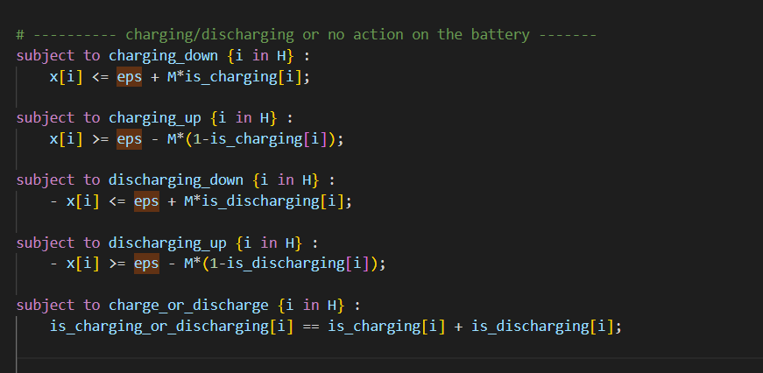

Then right before the profit function we can define what E_in and E_out are (as in the python code, see src/optimize and calculation of charge_energy and discharge_energy)

8. I am not sure about the usefulness of the use-case section about the stadium. It is not linked to how you wrote it or anything but it just doesn’t seem enough scientific to me in itself. What are your thoughts on this ?